🔹 Power Rail Check
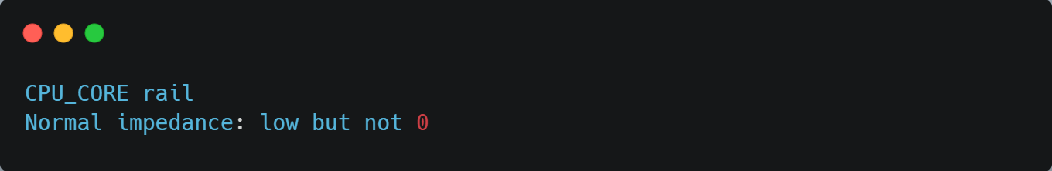
• 0Ω / very low → ❌ Short
• Normal value → ✅ Rail OK

🔧 Multimeter se Impedance kaise GUESS karte hain (Laptop Repair)
⚠️ Note:
Multimeter exact impedance measure nahi karta,
hum guess / compare karte hain.

1️ Concept – Repair me “Impedance guess” ka matlab
👉 Normal rail vs Short rail pehchanna
👉 Signal line bilkul dead to nahi
2️ Power Rail (DC) par Impedance Guess
🔹 Step-1: Meter → Resistance (Ω)
Board power OFF hona chahiye.
🔹 Step-2: Probe lagao
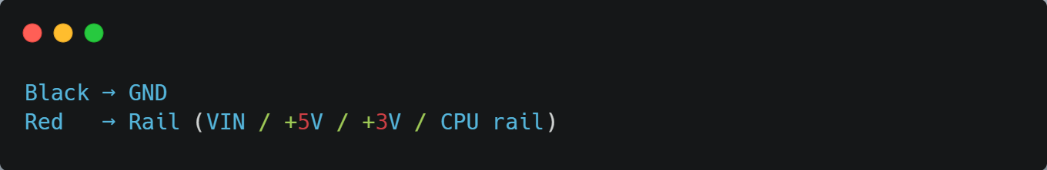

🔹 Step-3: Reading samjho
Reading | Matlab
0–2Ω | ❌ Hard short
5–20Ω | ⚠️ Suspect
30Ω – few hundred Ω | ✅ Mostly OK
Slowly OL ki taraf | ✅ Capacitors charging (Normal)
📌 CPU_CORE rail me 1–10Ω bhi normal ho sakta hai
(compare similar board se)
3️ Diode Mode Trick (Very Important 🔥)
🔹 Method
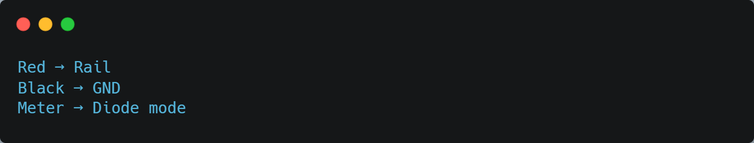
🔹 Result samjho
Reading | Meaning
0 / Beep | ❌ Short
0.1–0.2V | ⚠️ Heavy load
0.3–0.6V | ✅ Normal rail
OL | ❌ Open / disconnected
👉 Repair me diode mode impedance guess bahut use hota hai.
4️ Signal Line (CLK / DATA) par Guess
🔹 Continuity mode
- Signal → GND
- Beep aaya? ❌ Short to ground
🔹 Resistance
- kΩ – MΩ → Normal
- 0Ω → Short
📌 Exact impedance (50Ω / 90Ω)
multimeter se measure nahi hota,
sirf short/open detect hota hai.
6️ Real World Example
Doctor thermometer se
exact disease nahi,
sirf fever hai ya nahi dekhta hai.

Waise hi multimeter se
exact impedance nahi,
sirf rail healthy ya short judge karte hain.

DC = sirf Resistance
🔹 Fast signal = Resistance + Capacitor + Inductor = Impedance

